NJNAHRO AWARD RECEIPENTS BIO’S 2022
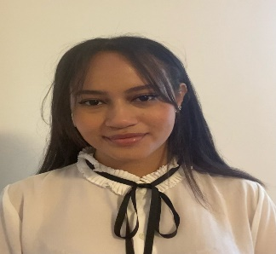

Mlak Hassan Award: $3,000
High School Youth – Secaucus High School - 3.155 GPA School: NJIT
Major: Psychology

Mlak Hassan is currently a senior at Secaucus High School with a GPA of 3.15. This year, Mlak scored the highest number of point in our evaluation system of all the submissions we received. Miss Hassan will study at NJIT and would like to become a Psychiatrist. In her essay she wrote about the importance of education instilled in her from a young age as she watched her father continue his education; earning his Master’s Degree at the age of 50. She feels that having access to quality education is a privilege that she will not take for granted.
Mlak has logged many hours of volunteer work assisting at Hudson Regional Hospital, participating in Secaucus Community Park clean-up days, and as a first-responder with the EMT training she received. She feels her life’s purpose is to provide useful assistance to people who are struggling with their mental health.
Her Honors of Human Anatomy teacher, Danielle Roberto indicated, Mlak challenges herself academically, receiving honor roll. She participates in numerous hours of community service and is a caring individual always willing to lend a hand. Michael Kelly, Mlak’s English teacher wrote, “Mlak has a great personality and is one of the nicest students I have ever had the pleasure to know. She is an intelligent leader who works hard in and outside of the classroom”.
Job Well done!

Ryan Vandermaas Award: $3,000
High School Youth – Newton High School - 3.86 GPA School: Montclair State University
Major: Undecided

Ryan VanderMaas is currently a senior at Newton High School, the President of his senior class and has a 3.86 GPA. Although he is not sure at this time what his major will be, he is grateful that he has the opportunity to attend college; an opportunity that was not offered his mother as she had to obtain work to support herself.
During his four years of high school Ryan has participated in many extracurricular activities which include participating in the marching band as the drum major, class president for 3 straight years, and selected for the leading role in his high school musical. He volunteers his time at several non-profit organizations and is a boy scout.
His band director, Stephen O’Toole stated “Ryan is an absolute pleasure to have in the instrumental music program. I’m always impressed with the amount of time Ryan commits to all of the groups he is in. He continues to be a leader and an asset to our program. I enthusiastically endorse Ryan and believe he is an excellent choice for your award”. His French teacher, Kathleen Leone said, “Ryan is a very intelligent, kind-hearted young man with strong convictions, a powerful voice and a genuine desire to learn”.
Good Luck, we know you will do well in college and beyond.

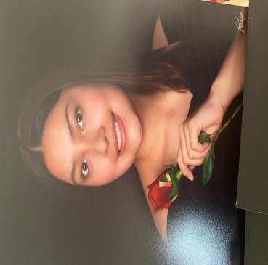

Isabella Diaz Award: $ 2,500
High School Youth – Boonton High School – 4.5 GPA School: Carnegie Mellon University
Major: Business

Isabella Diaz is currently a senior at Boonton High school with an impressive 4.5 GPA. She plans to attend Carnegie Mellon University in the Fall to study Business. Isabella states in her essay that her family endured years of financial issues as a result of bad money management decisions creating a never ending cycle of hardship. After enrolling in an accounting class and taking business finance her junior year of high school, she became intrigued with learning how to take control of her money. Isabella is a proud member of Future Business Leaders of Americas and plans to utilize the skills learned to help people organize themselves and take control of their credit and spending habits’ in order to see change in their financial lives for the better.
Elizabeth Cueto, VP-Market Administrator, Wells Fargo Advisors said in her recommendation letter on behalf of Ms. Diaz, “Isabella is an enthusiastic leader, often encouraging others to maximize their academic potential. Her work ethics is above par. She is intelligent, trustworthy and mature beyond her years”.
Kenneth Kelshall, FSS Coordinator at Boonton Housing Authority writes, Isabelle is an exemplary student who I have watched grow into a caring young lady. I have made several request to her for help with our annual community clothing and food drive and not only does she volunteer, she is the first one to arrive and does not leave until everyone is served. She is a young woman of great character.
Great Job – We wish her continued success!

Alexandra Vandermaas Award: $ 2,500
Continuing Education – Montclair State University – 2.96 GPA School: Montclair State University
Major: Music Education

Alexandra VanderMaas is currently a student at Montclair State University pursuing a career in music education. Her love for music includes learning how to play instruments which includes the guitar, ukulele, clarinet, saxophone, trombone, piano and cello. Since high school she has belong to several choirs throughout the state of NJ. Through the NJ Music Educators Association, she was chosen to represent Sussex County at the NJ Teen Arts Festival for vocal performance. This year, in addition to singing and learning how to play new instruments, Alexandra provided private voice lessons to other students.
Beth Roberts, Professor of Voice states, “Alexandra is an exemplary student, outstanding singer and musician, whose future is bright. After her outstanding contribution in the Vocal Pedagogy class I instructed, I immediately recognized her potential as a music educator and voice teacher. Alexandra volunteered her time to give lessons to fellow MSU students. She demonstrates leadership skills throughout the semester and inspires her classmates”.
Her beautiful voice and strong work ethics throughout the year is an example of why I believe she will make an excellent teacher said Dr. Stephen Oosting.
Continue to strive in all aspects of your life, as you are destined for SUCCESS!

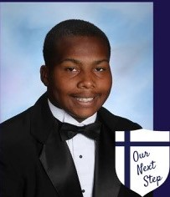

Dreveon Eddleman Award: $ 2,500
High School Youth – Morris Catholic High School - 3.155 GPA School: Monmouth University
Major:

Dreveon Eddleman is currently a senior at Morris Catholic High School with a 3.15 GPA. Dreveon participates in several extracurricular activities in school which include football, wrestling, track and Operation Smile. His life has been quite difficult he stated in his essay that at 7 years old his family became homeless. As a result, he attended many different schools during his early years and did not have the opportunity to make many friends. His family never gave up hope in spite of the challenges they endured. He stated he followed his mother’s lead and remained positive, faithful and hard working. “She is my hero”, he said, she taught me that when things get hard, to never quit! with faith, love and hard work, you can do anything.
In addition to participating in sports Dreveon volunteers to feed the homeless, helped to restore a neighborhood park and collect toys during the holiday for the less fortunate.
Ms. Lori Kretten, M.Ed., Guidance counselor, wrote in her recommendation letter that Dreveon is a passionate student, compassionate teammate and community/school leader. He approaches every day eager to embrace the opportunities and challenges in front of him and, in addition to his athletic achievements, he has a desire to serve others in meaningful ways. Helping special needs children play sports or volunteering with the Big Brother/Big Sister programs. He is an impressive young man.
Stay humble and willing to help others, your future is bright!

Nastasja Roman Award: $ 2,000
College Student – Centenary University – 2.6 GPA School: Centenary University
Continuing Ed. Major: Theater Education

Nastasja Roman is currently enrolled at Centenary University pursuing a degree in Theater Education. She indicated in her essay that as the oldest child in the family she was always teaching her siblings new things. Her ambition is to teach special education students because she struggled throughout her early years at school due to low self-esteem, a lack of confidence, and the belief that no one could or wanted to help her. Getting involved in music made her finally feel like she belonged and could contribute something and have fun with her peers while learning.
She is determined to graduate and make your family proud. She understands that she is a role model for her younger siblings and will be the first in her family to attend and graduate college.
Melanie Miller, Ph.D., Pastor-AME Zion Church stated that Nastasja is an active member who conducts outreach and missions to the community and around the world. She further states that she provided support during the COVID-19 pandemic providing information on the vaccination in the community.
we wish you continued success.

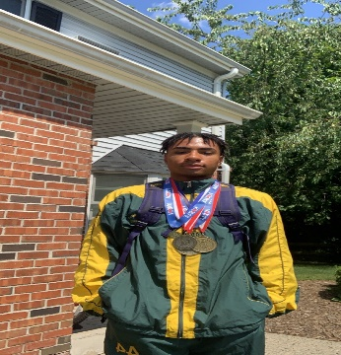

Laron Blackwell Award: $ 2,000

High School Youth – Morris Knolls High School - GPA 81.5 School: CCM
Major: Undecided

Laron Blackwell is currently a senior at Morris Knolls High School and will graduate June 2022. He is interested in attending several school but has not made a final decision yet. On his application submission he lists Rutgers, Ramapo and Bloomsburg Universities as schools he would like to attend in the fall. His hobbies include working out, listing to music and running track.
Christopher Roman, School Counselor stated in his letter of recommendation that he has worked with Laron since freshman year and he has demonstrated an ability to conduct himself in a mature and professional manner. He is respectful and polite and can be introspective. Further, he understands what it takes to succeed and has the ability to do what is necessary. Recently Laron was crowned the Morris County champion in the 110-meter hurdle event running what is currently the fastest time in NJ. He works extremely hard to get where he is, and now stands out as leader on the track team. I expect Laron to do great things in the future.
His science teacher, Laura Malec, said “I observed Laron’s interest in science and was pleased to see him challenge himself in the classroom. I am very impressed at how Laron approaches assignments where he has to utilize and further develop his critical thinking and analysis skills.” She believes that he will continue to grow academically and be an asset to the community for years to come.

Yoelis Avilez Award: $ 2,000
College Student – Berkeley College - 3.155 GPA School: Berkeley College
Continuing Ed. Major: Health Services Administration

Yoelis Avilez is currently enrolled at Berkeley College as a freshman student and plans to graduate with a degree in Health Services Administration in 2024. Yoelis is a single mother of three children. She stated in her essay that her children are her motivation and strength. She is attending college in order to give her children a better life. She would like to one day own her own business, say goodbye to government programs, and purchase a home for her family. She stated she wants to be a role model that her children can feel proud of.
Professor, Dr. Mandanna Naleyanda, stated in her recommendation letter that she found Yoelis to be a very hard working dedicated student who is always eager to learn. She further stated that Yoelis has currently attained 94% in her class and she firmly believes that she will make lasting contributions to her community.
Professor, Rebecca Ruballos indicated that Yoelis is conscientious student who makes a point of submitting all of her work on time. She pays close attention to the standard of her work ensuring that it is of outstanding quality. She is impressed with her ability to balance the responsibilities of school, work and home. She is a great role model to everyone.

